RESOLUTION NO.__________

RE: CERTIFICATE OF APPROPRIATENESS UNDER THE
PROVISIONS OF THE ACT OF THE PENNSYLVANIA
LEGISLATURE 1961, JUNE 13, P.L. 282 (53
SECTION 8004) AND BETHLEHEM ORDINANCE NO.
3952 AS AMENDED.

The applicant proposes to a corporate sign, flush mounted on the brick wall
utilizing existing mounting holes at 7 E. Church St.

NOW, THEREFORE, BE IT RESOLVED by the Council of the City of Bethlehem that a Certificate of Appropriateness is hereby granted for the proposal.

Sponsored by: (s)

(s)

ADOPTED BY COUNCIL THIS DAY OF

(s)
President of Council

ATTEST:

(s)
City Clerk

HISTORICAL & ARCHITECTURAL REVIEW BOARD

The applicant proposes to install a corporate sign, flush mounted on the brick wall utilizing existing mounting holes at 7 E. Church St.

APPLICATION #7:

Genevieve Marcon
55 East Church St.
Bethlehem, PA 18018

OWNER:

__________________________________________________________________________

The Board upon motion by Beth Starbuck and seconded by Connie Postupack adopted the proposal that City Council issue a Certificate of Appropriateness for the following:

- Installed sign to be non-serif letters.

2. Lettering and pinstripe to be dark green.

3. The background to be tan to match the brick mortar.

4. The motion was unanimously approved.

__________________________________________________________________________

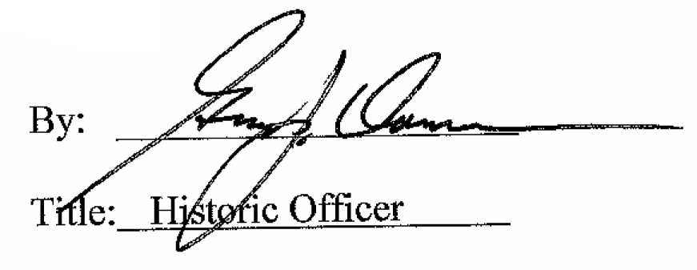

Date of Meeting: May 2, 2018

